Module 3 Task Linux:-

**Scenario There is a customer who came to you with a problem to have a custom linux command for his operations. Your task is to understand the problem and create a linux command via bash script as per the instructions. Command name - internsctl Command version - v0.1.0**

Section A 1. I want a manual page of command so that I can see the full documentation of the command. For example if you execute the command man ls as output we get the doc and usage guidelines. Similarly if I execute man internsctl I want to see the manual of my command.

Output:-

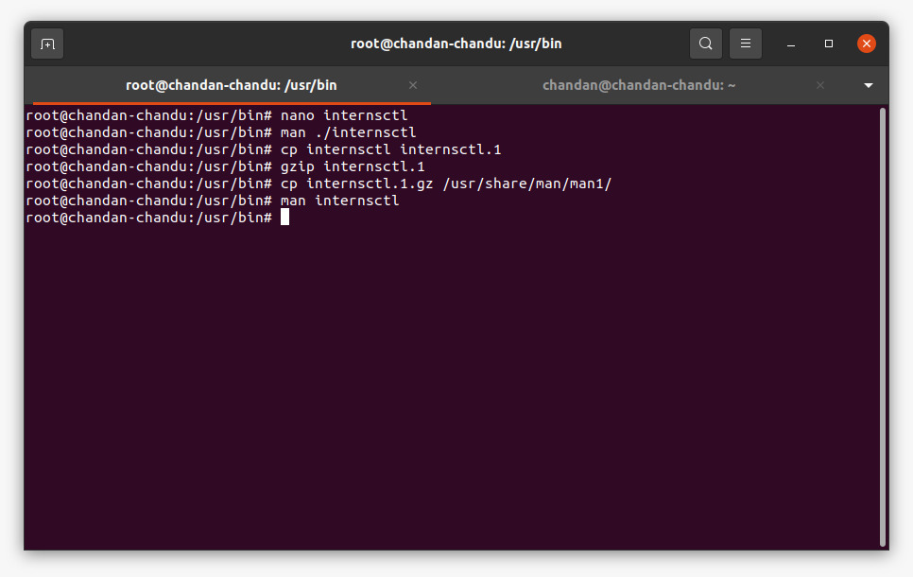

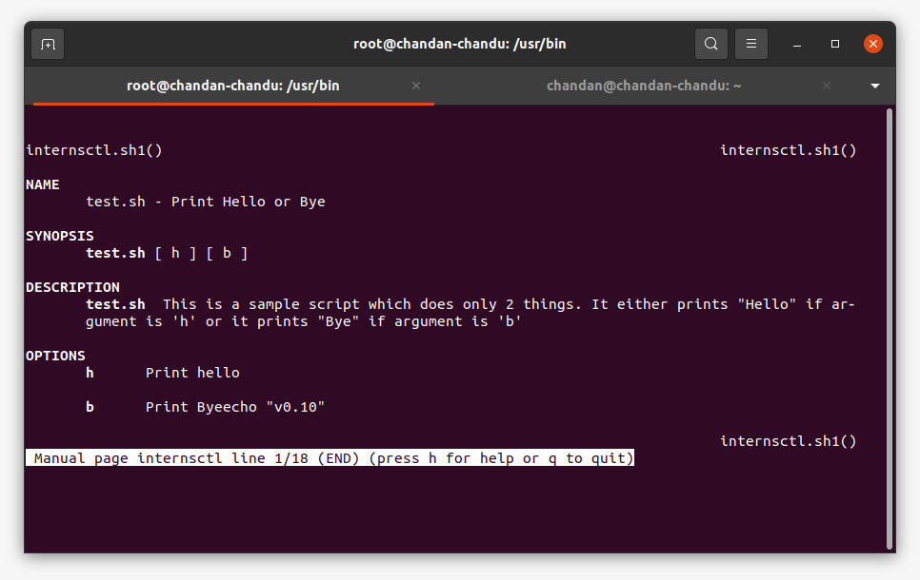

2. Each linux command has an option --help which helps the end user to understand the use cases via examples. Similarly if I execute internsctl --help it should provide me the necessary help

Output: 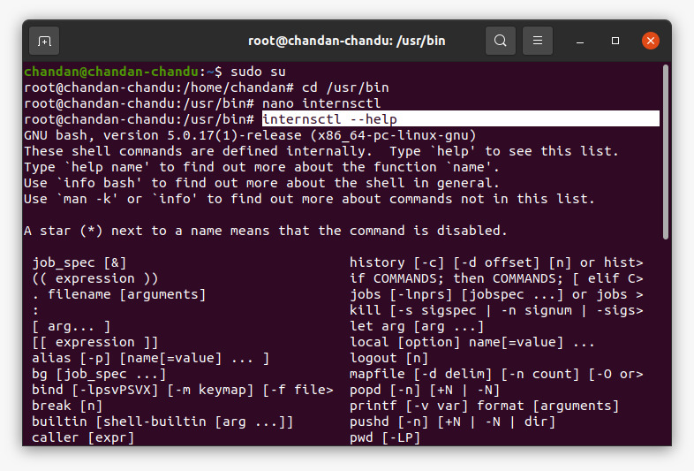

3. I want to see version of my command by executing internsctl –version

Output:

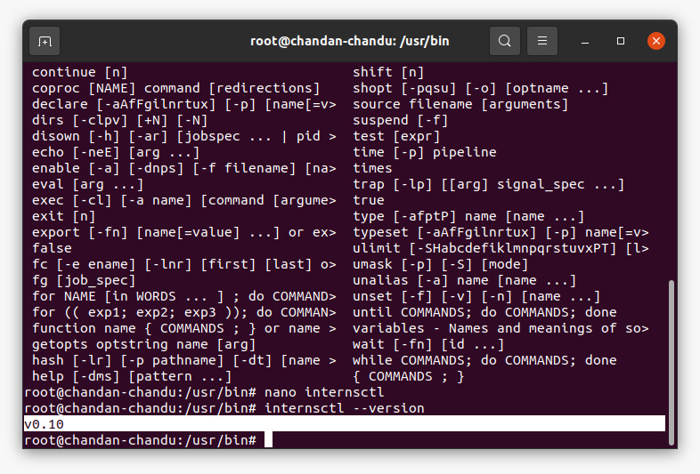

**Section B**

**I want to execute the following command for –**

Part1 | Level Easy

I want to get cpu information of my server through the following command:

$ internsctl cpu getinfo

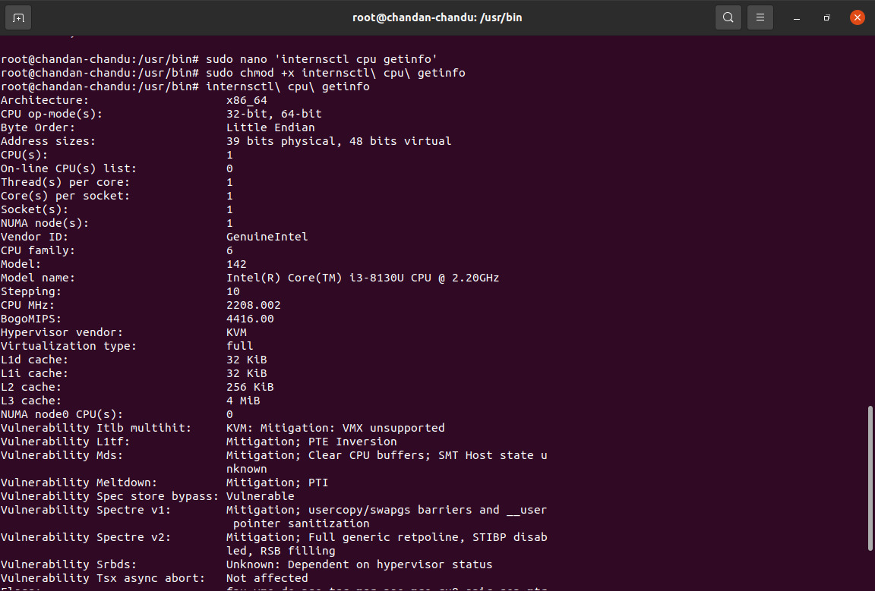

**I want to get memory information of my server through the following command:**

**$ internsctl memory getinfo**

Expected Output I want similar output as we get from free command

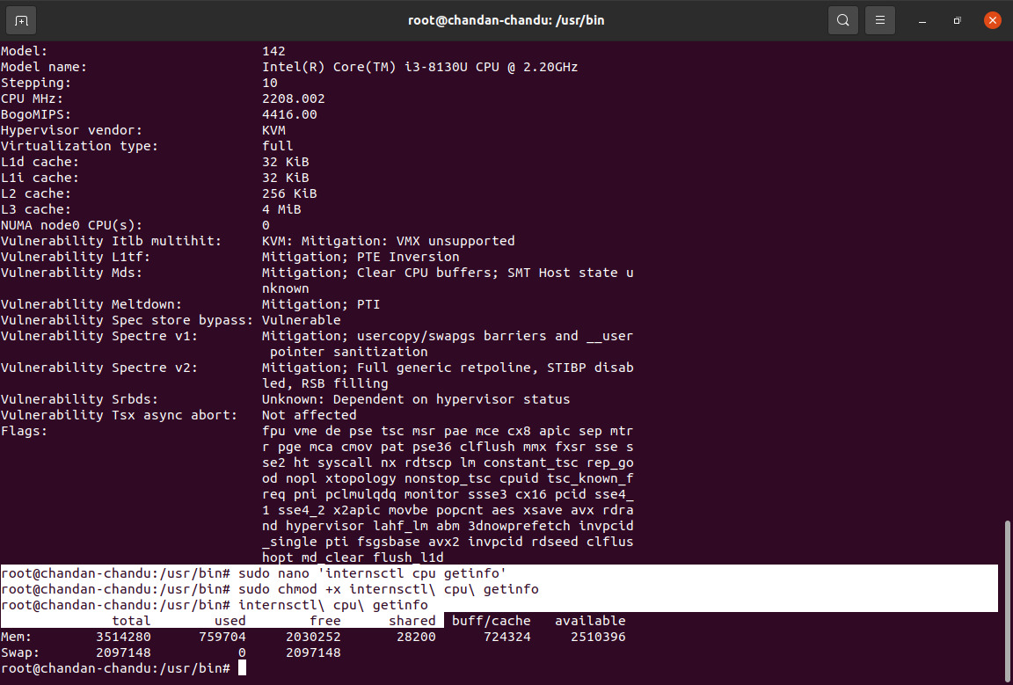

**Part2 |**

**Level Intermediate**

**I want to create a new user on my server through the following command:**

**$ internsctl user create**

Note - above command should create user who can login to linux system and access his home directory --- I want to list all the regular users present on my server through the following command:

$ internsctl user list --- If want to list all the users with sudo permissions on my server through the following command:

$ internsctl user list --sudo-only

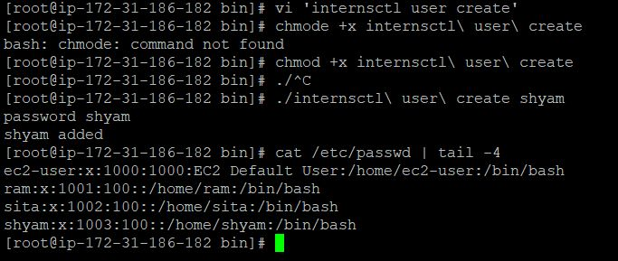

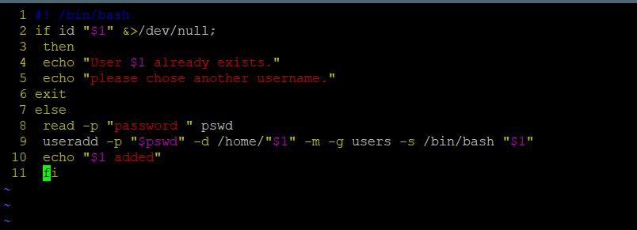

**Part3**

| Advanced Level By executing below command

I want to get some information about a file

$ internsctl file getinfo

Expected Output

[make sure to have the output in following format only]

xenonstack@xsd-034:~$ internsctl file getinfo hello.txt

File: hellot.txt

Access: -rw-r--r—

Size(B): 5448

Owner xenonstack

Modify: 2020-10-07 20:34:44.616123431 +0530

In case I want only specific information then I must have a provision to use options

$ internsctl file getinfo [options]

--size, -s to print size

--permissions, -p print file permissions

--owner, o print file owner

--last-modified, m

